Biology Review Day 2: Unit 2 Ecology, Ch 3-6
Answer your questions on your own paper! These are LONG answer questions!
- What is a decomposer?
- What is a producer? Give another name for this. (---troph)
- What a consumer? Give another name for this. (---troph)
- What influence do decomposers, producers, and consumers have on an ecosystem?
- Can some organisms survive without energy from the sun? Explain your answer.
- What is a food chain? A food web?
- How do we use food webs and energy pyramids to show the flow of energy through an ecosystem?
- What is the water cycle, and how does it work?
- What is the carbon cycle, and how does it work?
- How do the biogeochemical cycles support the Law of Conservation of Matter?
- What are some factors that influence population size?
- How do multiple factors interact to determine population size?
- How can we describe the conditions that may cause changes in ecosystems over time?
- What is the difference between primary and secondary succession?
- How is life distributed and varied in ocean? (Hint: Think ZONES)
- How do multiple factors (chemistry, depth, salinity, light, and temperature) affect the distribution and variation of life in aquatic systems?
- What are the major causes and effects of the loss of biodiversity?
- How can we predict the impact that human activities have on environmental systems and sustainability?

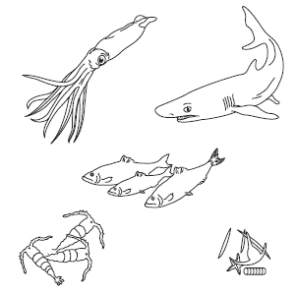
- Draw arrows between the organisms to show how energy moves through this food chain. Write producer, herbivore, or carnivore under each organism.

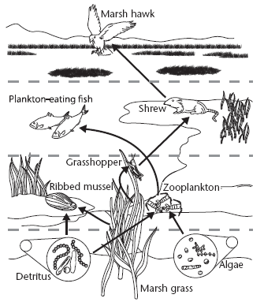
Use the diagram to answer Questions 10–17.
Match the organism with its trophic level. A trophic level may be used more than once.

Organism
10. algae
11. grasshopper
12. marsh grass
13. marsh hawk
14. plankton-eating fish
15. ribbed mussel
16. shrew
17. zooplankton
Trophic Level
A. primary producer
B. first-level consumer
C. second-level consumer
D. third-level consumer

18. A bird stalks, kills, and then eats an insect. Based on its behavior, which pair of ecological terms describes the bird?

a. herbivore, decomposer
b. producer, heterotroph
c. carnivore, consumer
d. autotroph, herbivore

19. Carbon cycles through the biosphere in all of the following processes EXCEPT

a. photosynthesis.
b. transpiration.
c. burning of fossil fuels.
d. decomposition of plants and animals.

20. Which of the following is NOT one of the factors that play a role in population growth rate?
a. immigration c. emigration
b. death rate d. demography

