Biology Review Day 3: Unit 3 Cells, Ch 7&10
Answer your questions on your own paper! These are LONG answer questions!
- What are the tenets of cell theory?
- What is the relationship between a theory and a law?
- What role did scientific claims and argumentation have in the development of a scientific cell theory?
- How has the development of the microscope contributed to cell theory?
- What is the relationship between the structure and function of the major cell organelles found in plant and animal cells?
- How do prokaryotic and eukaryotic cells compare?
- How does the cell membrane regulate the movement of materials into and out of the cell?
- How do concentration gradients impact the movement of materials across the cell membrane?
- How do active and passive transport compare?
- How can we describe the stages in the life cycle of a cell?
- What is mitosis?
- What are the stages of mitosis?
- What impact can mutations and uncontrolled cell growth have on the cell cycle?

Prokaryotes are simple cells. They lack a nucleus. Your body is made up of eukaryotic cells. Eukaryotes have a nucleus that holds DNA. They also have organelles.
Look at the diagrams below. Follow the directions.
1. Label the prokaryotic cell.
2. Label the eukaryotic cell.
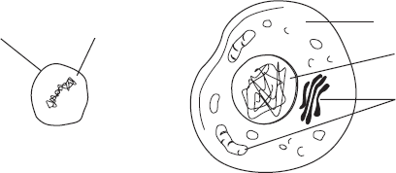
Cytoplasm
Cell membrane
Cytoplasm

Nucleus

Organelles

Mitosis is the process by which the nucleus of most eukaryotic cells divides. Mitosis has four phases: prophase, metaphase, anaphase, and telophase.
Follow the directions.
1. Label the four phases of mitosis in the diagram.
2. Label the spindles and centrioles in one of the phases.
3. Color each chromosome in prophase a different color. Follow each of these chromosomes through mitosis. Show this by coloring the correct structures in each phase of mitosis.

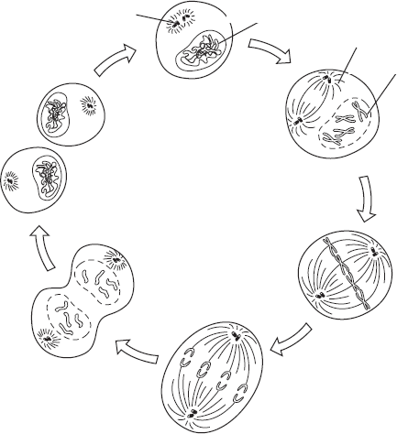
Cytokinesis
Interphase
Chromosome
Chromatin

Answer the questions.
4. In which phase do the chromosomes line up in the middle of the cell?
5. In which phase do the chromosomes become visible?
6. In which phase do the chromosomes move until they form two groups near the poles of the spindles?

Use the words below to label the plant cell. Some structures have been labeled for you.
cell wall mitochondrion ribosome
chloroplast nucleus vacuole

Plant Cell
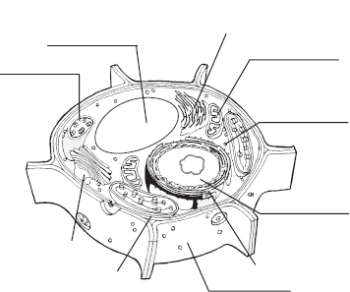
smooth endoplasmic reticulum

rough endoplasmic reticulum
Golgi apparatus
cell membrane

2. Use the words below to label the animal cell. Some structures have been labeled for you.
cell membrane mitochondrion rough endoplasmic reticulum
Golgi apparatus nucleus ribosome

Animal Cell
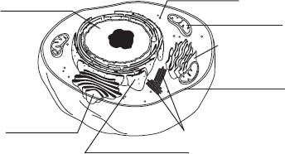

smooth
endoplasmic
reticulum

centrioles

An organelle is a specialized cell structure. Each organelle functions in a different way. All of the organelles help the cell carry out life processes.
Use the terms in the box to write the name of the organelle underneath its picture.
endoplasmic reticulum Golgi apparatus mitochondrion nucleus

Organelle | Function
 | Controls most cell processes and stores genetic material
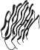 | Where lipid parts of the cell membrane and proteins for export are assembled and stored
 | Modifies, sorts, and packages materials from the endoplasmic reticulum
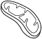 | Converts the energy stored in food into a more usable form

1. Which of the following is a function of the cell membrane?
a. breaks down lipids, carbohydrates, and proteins from foods
b. stores water, salt, proteins, and carbohydrates
c. keeps the cell wall in place
d. regulates the movement of materials into and out of the cell
2. Looking at a cell under a microscope, you note that it is a prokaryote. How do you know?
a. The cell lacks cytoplasm. c. The cell lacks a nucleus.
b. The cell lacks a cell membrane. d. The cell lacks genetic material.
3. Which sequence correctly traces the path of a protein in the cell?
a. ribosome, endoplasmic reticulum, Golgi apparatus
b. ribosome, endoplasmic reticulum, chloroplast
c. endoplasmic reticulum, lysosome, Golgi apparatus
d. ribosome, Golgi apparatus, endoplasmic reticulum

