Name _________________________________________________ Date ____________________________________ Period __________
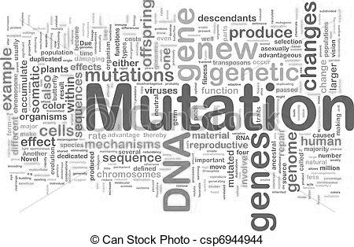
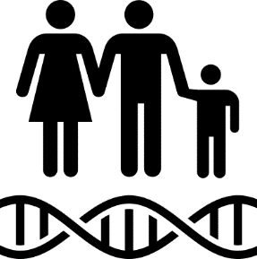
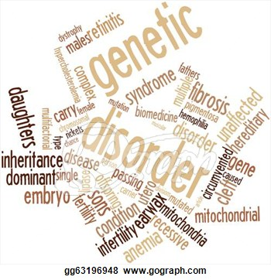
5E Lesson Unit 6 – Nucleic Acids: Mutations
Standard – As a student, I should be able to…
- SC.912.L.16.4 Explain how _________________ in the DNA sequence __________________________ result in ___________________ change. Explain how mutations in _______________ may _______________________________ in offspring.
- HE.912.C.1.7 Analyze how heredity and family history can impact personal health.
Guiding Questions – As a student, I should be prepared to correctly answer the following on a test:
- How can we describe the impacts of ____________________________________________________ that may occur in a DNA _________________?
Telephone Game Discussion
- Why did the original message differ from the end message?
__________________________________________________________________________________________________
- Similarly, __________________ in the message, or _________________________, can occur as they are ______________________________________________________________________.
Mutations
- Mutations = _________________________________________________________________________________________________
- __________ of the DNA in an organism’s ___________________ (total DNA) is _____________________, or “junk DNA”
- Changes to a DNA sequence __________________________ does not affect protein production and, therefore, __________________________________
2 Categories of Mutations
- __________________________ involve changes in one or a few nucleotides = _______________________________
- __________________________ involve changes in the number or structure of chromosomes
Gene/Point Mutations
- Occur at a ____________________________ in the DNA sequence
- __________________ = __________________ “subbed”/_______________ for another, usually affect no more than a ______________________________
- __________________ = __________________ into the DNA sequence, an extra letter ___________________________
- __________________ = _________________ from the DNA sequence, a missing letter ___________________________
**Make your gene/point mutation index cards, you have 10 minutes!**
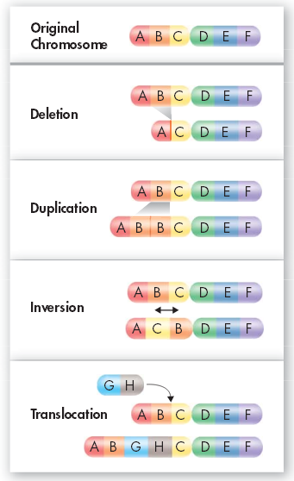
Chromosomal Mutations
- Involve changes in the number or structure of chromosomes
**Make your chromosome mutation index cards, you have 10 minutes!**

Use 13.2 in the textbook

Effects of Mutations Essay
- 2-3 paragraph essay including examples & descriptions of the following topics:
  - Gene vs. chromosome mutations
This website is VERY helpful!
http://learn.genetics.utah.edu/content/history/
  - Harmful & helpful mutations
  - Frameshift mutations
  - Effect of mutations on living things
  - How might scientists determine if a mutation has occurred in a species?
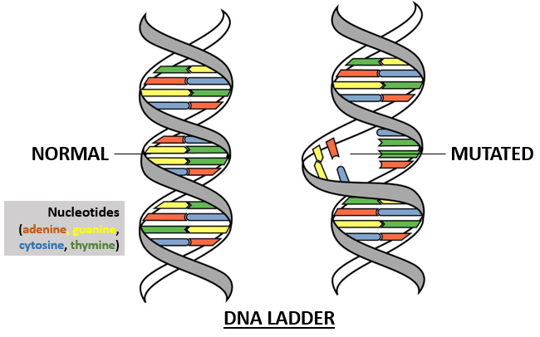
What you don’t finish in class is …

- Turn in the essay AND flash cards next class!!

