Name _______________________________________ Date _____________________ Period ___________
Biology: Chapter 1 Notes
Directions: Fill in the blanks with the purple text from the PowerPoint. Keep this page in your notes.
Biology = _________________________________
What is Life?
- 1. ___________________ –_____________: includes all organisms, water, land, and air
- 2. ___________________ – living things
- _______________________________ – the thought that living things come from non-living things (bees / flies) ______________________________________
Life
- _________________ – living things come from other living things
  - ________________________________________________________
  - examples: butterflies, frogs, humans, plants
- __________________________: how do we put order to living things?
  - There are so many, we must have a way to know what we are talking about, no matter where we are in the world.
Living Things
- Cell – smallest unit of living things. Some organisms are made of only 1 cell (_____________) others are made up of many cells (______________________)
  - The cell is the “_____________________________________”
Characteristics of Living Things
- _______________ – ability to do work (this can ________________________________________________________________)
  - Ice to Water to Steam
- _________________- ____________________________ of a living thing.
- Development – change in ________________________________ of a living thing.
- _____________________ – making of new cells from living cells that already exist.
- Response – how living things ________________________________________.
- Adaptation – __________________________________________ and then these responses are ________________________________________. (appendix / hair)
Levels of Organization
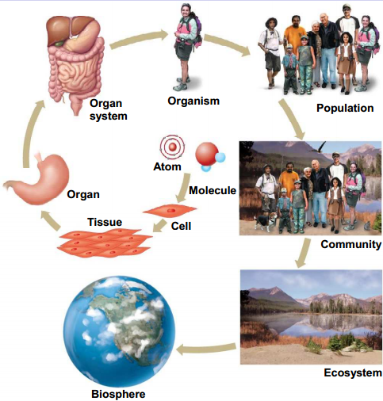
- ________________ – _________________________ working together for a function.
- ______________ – _________________ (____________________) working together for a specific purpose.
- System – several organs working together for a ________________________________.
- __________________ – A living thing, made up of several systems that ________________________________________________ in a niche.
- Niche – a small environment where organisms ___________________. (area just their own)
- What is a predator? ______________________________________________________
- What is prey? ___________________________________________________________
Lab Report
1. ______________- Name for the lab or experiment
2. ___________________ - why we do the lab, what are we doing. Explained in 1 or 2 sentences. (logical guess)
3. ________________ – Items and equipment needed for the lab. (often in a list format)
4. ________________ - How to do the lab (dry example or walk through)
5. ________________________ – what is taking place, what do you see or observe? (charts, graphs, times, pictures, drawings, etc.) ____________________________!
Examples
- Variable: _________________ in the experiment?
- Control / constant: _______________________________________________________
- Theory: is a ______________________________ hypothesis. Lasts over time…..
Lab Report
6. Conclusion - result, __________________________________________________________________________________________________________________________________________________________

