Life – Hunters and Hunted
Based on the BBC Life Series

- The coalition of cheetahs attempts to hunt zebra, then an ostrich. Describe how their tactics differ between the two hunts. Which one is successful, and why?

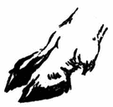
- What physical adaptations are present in ibex that helps them thrive in such a mountainous area?

- Describe the hunting techniques used by the greater bulldog bat. How do the bats coordinate so they don’t collide?

- How does the play-fighting behavior of the stoat correlate with its hunting of a much larger species, the rabbit?

- The hunting grounds of the bottlenose dolphin are littered with strange circular patterns throughout the sandy bottom of the water. Explain how their hunting produces these patterns.

- The brown bears have to gamble every year that they will successfully locate the spawning salmon. Why is this an important find for them?

- The behavior and hunting of Ethiopian wolves is much different than their European and American cousins. Explain the difference, and relate it to the ecosystem they live in.

- The star-nosed mole is an unusual mammal in that it can hunt both underground and underwater. Explain how.

- Chital deer graze in a forest that is full of noises and other distractions that make it hard to single out the approach of a predator, such as the Bengal tiger. How do they overcome this challenge?

- Explain how the California ground squirrel is able to fend off a snake – a predator that relies mainly on its sense of smell and the ability to detect heat.

- What hunting strategy does the female orca (killer whale) have that no other known individuals have? Explain how, given the process of natural selection, this skill could work its way through the entire orca population given enough generations.

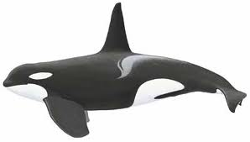

Order Chiroptera
“Adapted for Flight”
Order Perissodactyla
“Odd-Toed Hooved”
Order Primates
“Opposable Thumbs”
Rodentia
“Gnawing Hervivores”
Hyracoidea
“Short legs and tail”
Tubulidentata
“Tube-Toothed”
Order Marsupialia
“Pouched”
Order Soricomorpha
“Shrew-like Insectivores”
Order Monotremata
“Egg Layers”

Cetacea
Order Proboscidea
“Elongated Mouthpart”
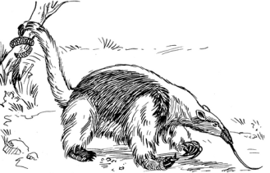

Order Sirenia
“Aquatic Herbivores”

Xenartha
Order Xenarthra
“Toothless”

Class Mammalia
Phylum Chordata

Order Artiodactyls
“Even-Toed Hooved”
Order Carnivora
“Sharp-Tooth Meat Eaters”
Order Lagomorpha
“Jumping Herbivores”
Order Cetacea
“Aquatic Carnivores”

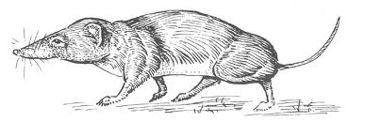

Eulipotyphla
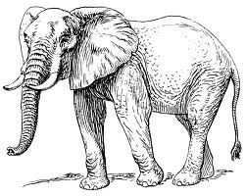

Proboscidea
List each species of mammal in this episode of Life. Put a check under the column for the order it belongs in, then visit www.iucnredlist.org and find its conservation status. If the animal is not listed, write “not available.”

 | Monotremata | Proboscidea | Sirenia | Xenarthra | Lagomorpha | Carnivora | Artiodactyla | Cetacea | Marsupialia | Tubulidentata | Hyracoidea | Rodentia | Primates | Perissodactyla | Chiroptera | Soricomorpha | IUCN Redlist Status
Cheetah
Walia Ibex
Greater Bulldog Bat
Stoat
Bottlenose Dolphin
Brown Bear
Ethiopian Wolf
Star-Nosed Mole
Chital
California Ground Squirrel
Orca

