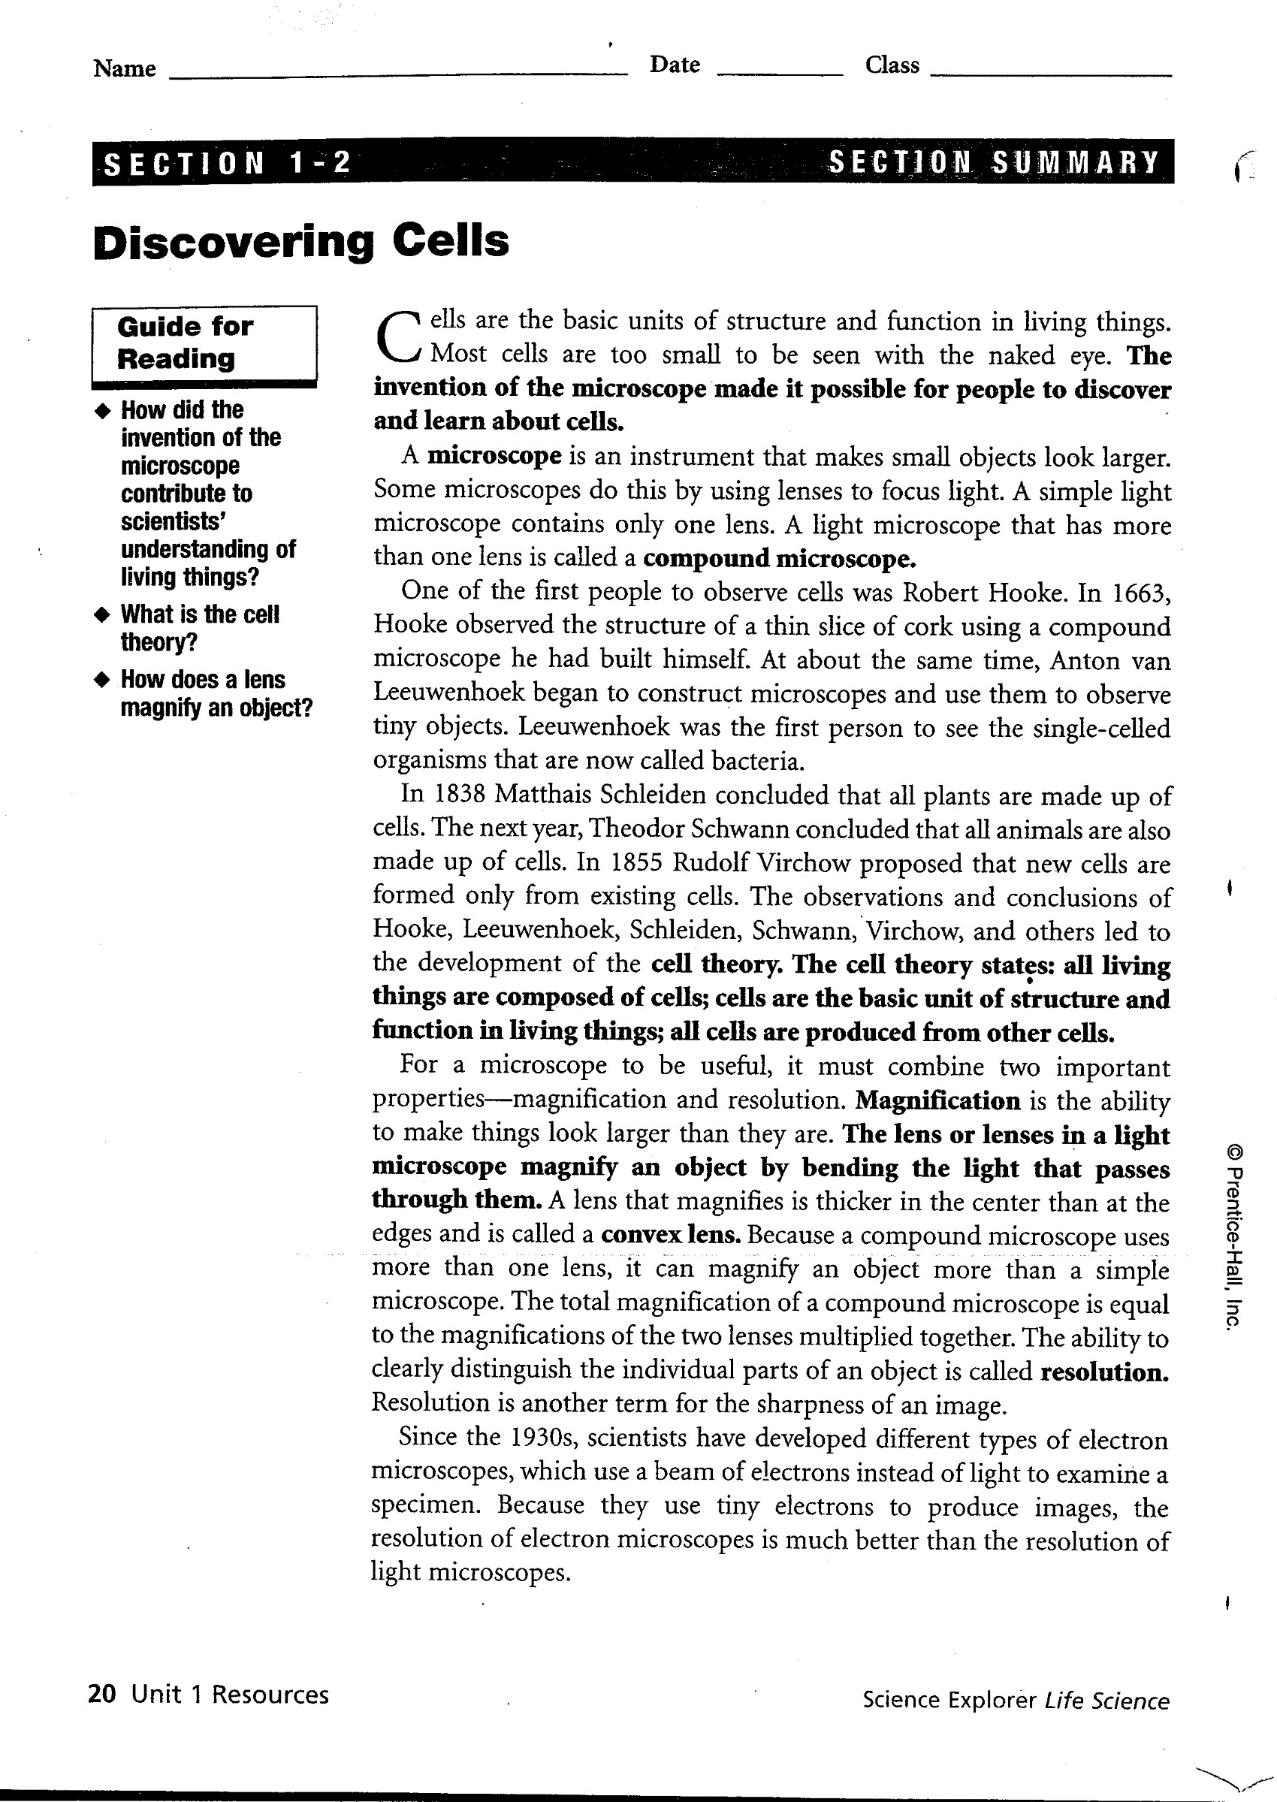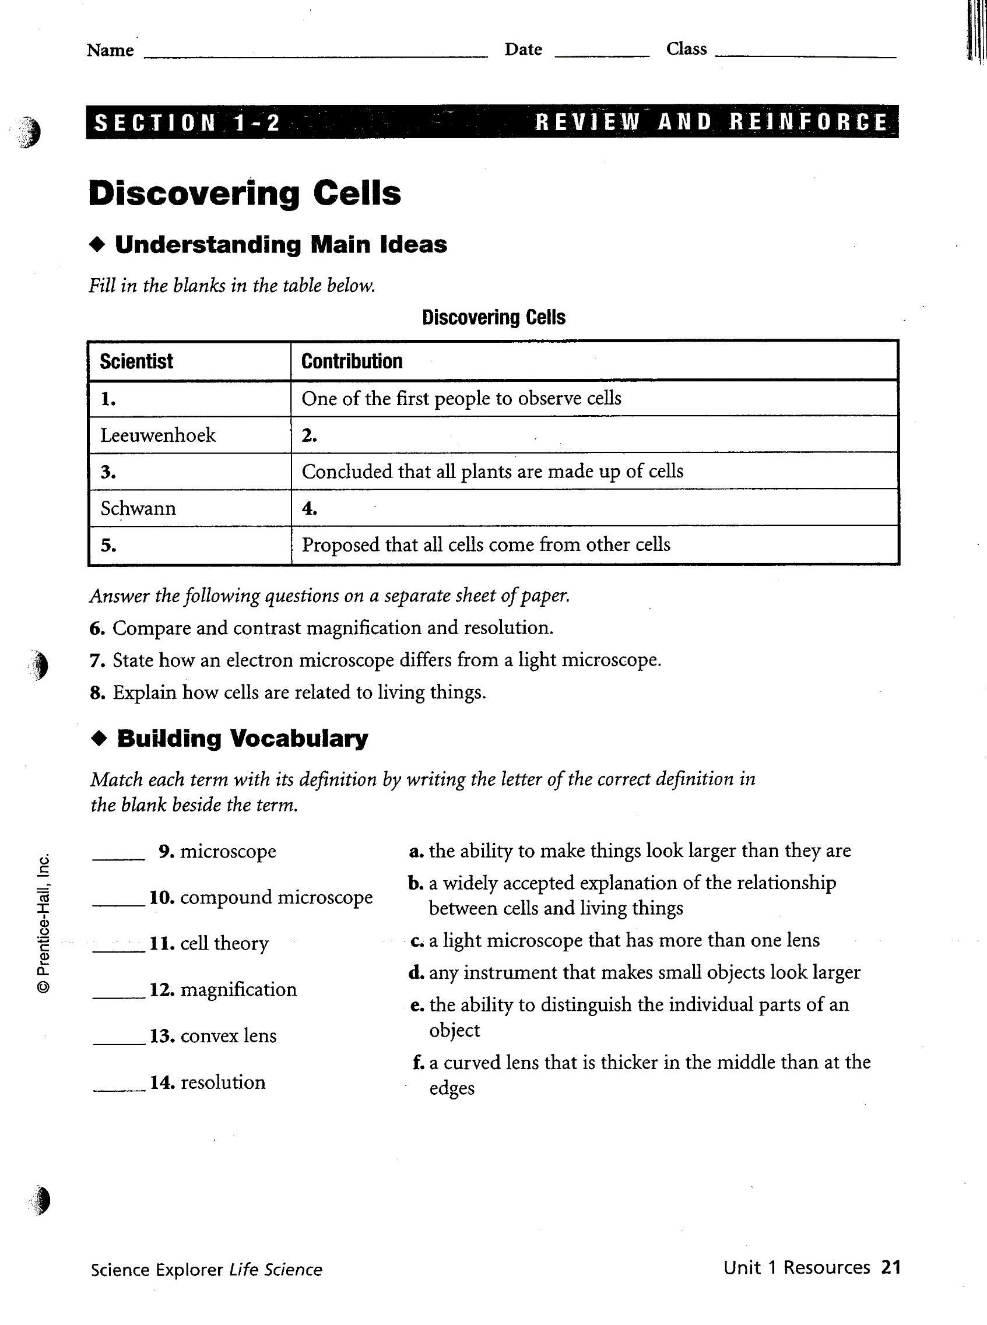

Name ________________________________________ Date ______________ Period __________

**Reinforcement Worksheet – Cell Theory, Scientists, & Cell Types**

**KEY CONCEPT** Cells are the basic unit of life.

The invention of the microscope in the late 1500s revealed to early scientists a whole new world of tiny cells. Most cells are so small that they cannot be seen without a microscope. The discoveries of scientists from the 1600s through the 1800s led to the cell theory, which is a unifying concept of biology. The cell theory has three major principles:

• All organisms are made of cells.

• All existing cells are produced by other living cells.

• The cell is the most basic unit of life.

All cells can be divided into two major groups: prokaryotic cells or eukaryotic cells. The main differences between the two kinds of cells are in their structure:

• Eukaryotic cells have a nucleus defined by a membrane, while prokaryotic cells have no nucleus.

• In eukaryotic cells, the DNA, or genetic information, is found in the nucleus. In prokaryotic cells, the DNA is found in the cytoplasm, the jellylike substance

that fills both types of cells.

• Eukaryotic cells have organelles, structures that perform jobs for a cell. Most organelles are surrounded by membranes. Prokaryotic cells do not have organelles surrounded by membranes.

Prokaryotic cells make up organisms called prokaryotes. All prokaryotes are tiny and consist of single cells. Bacteria are prokaryotic cells. Eukaryotic cells make up eukaryotes. You are a eukaryote, as are plants and some types of single-celled organisms. All multicellular organisms, or organisms that have many cells, are eukaryotes.

1. What is the smallest, most basic unit of life? ____________________________________________

2. Where is the DNA in a prokaryote? in a eukaryote?

__________________________________________________________________________________

__________________________________________________________________________________

3. Why would you need a microscope to see a prokaryotic organism?

__________________________________________________________________________________

__________________________________________________________________________________

4. A friend tells you he read somewhere that rotting garbage can turn into maggots, which are fly larvae, and the maggots then can grow into adult flies. What part of the cell theory could you use to refute his claim?

__________________________________________________________________________________

__________________________________________________________________________________

**MAIN IDEA:** Early studies led to the development of the cell theory.

In a phrase for the table below, tell what each scientist did to help develop the cell theory.

|  |  |
| --- | --- |
| **Scientist** | **Contribution to Cell Theory** |
| 1. Hooke |  |
| 2. Leeuwenhoek |  |
| 3. Schleiden |  |
| 4. Schwann |  |
| 5. Virchow |  |

What are the three parts of the cell theory?

__________________________________________________________________________________

__________________________________________________________________________________

__________________________________________________________________________________

**MAIN IDEA:** Prokaryotic cells lack a nucleus and most internal structures of eukaryotic cells.

In the top left side of the Y shape below, write the characteristics of eukaryotic cells. In the top right side of the Y shape below, write the characteristics of prokaryotic cells. At the bottom of the Y shape below, write the characteristics that both kinds of cells have in common.

