Cell Theory & Cell Intro Match
Find the appropriate items that relate to the cell theory scientists, prokaryotes/eukaryotes, etc. Write their corresponding letter on the answer sheet.
Earth’s first cells  A | 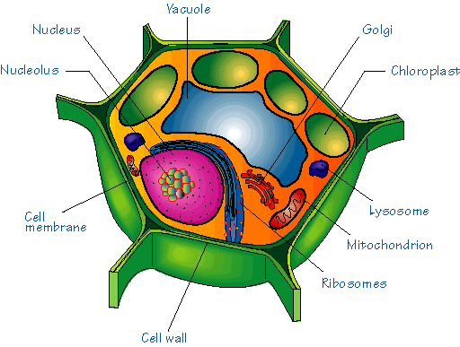B | All living things are composed of cells  C | Designed a microscope to observe microorganisms D
Arose from simpler cell types  E | His study concluded that new cells can only come from existing cells F | 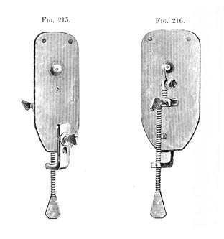G | 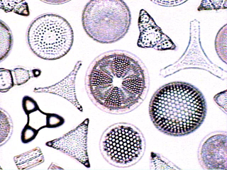 H
Includes bacteria  I | Have chloroplasts, a cell wall, and a large central vacuole  J | 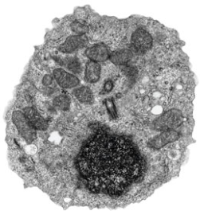 K | Observed ‘rooms’ in dead cork, and coined the term “cells”  L
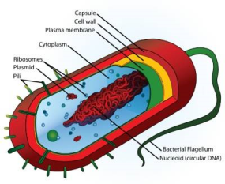 M | Cells are the basic units of structure and function in living things N | Includes animals, plants, fungi and protists O | 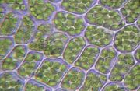  Concluded that plants were made up of cells  P
Observed bacteria and protists in pond water Q | Larger and more complex cells  R | Biologist who concluded animals were made of cells  S | Lack nuclei and membrane-bound organelles T
Earth’s most abundant  inhabitants and the simplest cellular life form U | V | His findings  disproved the idea of spontaneous generation W | 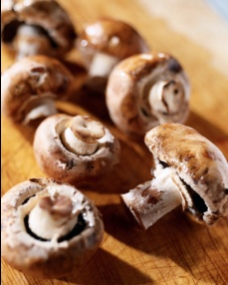X
Genetic material is surrounded by a nuclear membrane  Y | 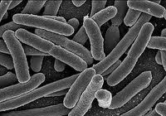 Z | Can survive in a variety of environments  5 | New cells are produced from existing cells  7

Traditional Cell Theory and Cell Intro Match Game
Use the grid of 28 boxes on the other page to identify which box belongs to which category. Write the letter of the box from the grid under the appropriate topic/person. The number of boxes below the topic/name relates the number(s) of boxes belonging to it.
HINT: Cross out the boxes that you already used to help narrow down your choices
Box A has been done for you already.

Traditional Cell Theory |  |  |  |  |  |  |  |  |  |  | Rudolph Virchow |  |  |  | Matthias Schleiden
Anton van Leeuwenhoek |  |  |  |  |  |  |  |  |  |  | Robert Hooke |  |  |  | Theodor Schwann
Prokaryotes
A
Eukaryotes |  |  |  |  |  |  |  |  |  |  |  |  |  |  | Animal Cells

Plant Cells

