Directions:
- Color & label all pictures (before making any cuts) to match the images provided on the smart board.
- Cut along the dotted lines for each picture and glue into your foldable. If there is any overlap, glue what will fit and fold the remainder back over the picture.
Light-Dependent Reactions
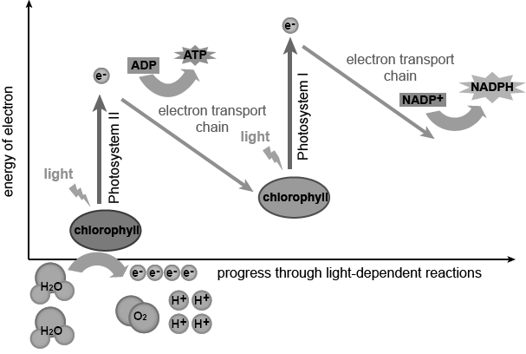

Light-Independent Reactions
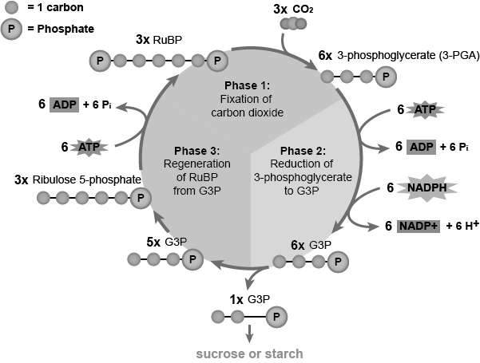

Summary of both Light-Dependent (left) and Light-Independent (right) Reactions
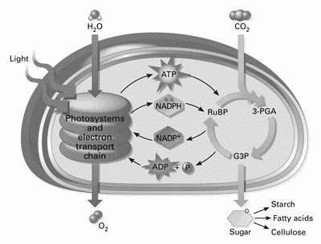
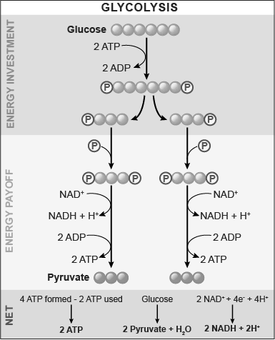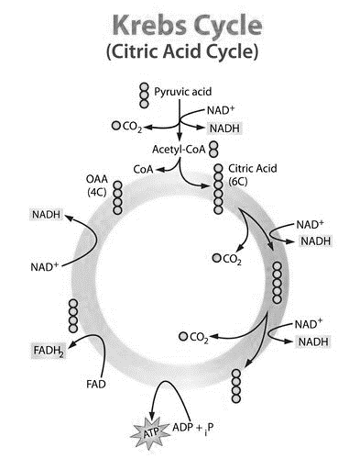

Electron Transport Chain
