Evidence for Evolution Poster Presentation Investigation (100 pts.)
Standard:
SC.912.L.15.1 Explain how the scientific theory of evolution is supported by the fossil record, comparative anatomy, comparative embryology, biogeography, molecular biology, and observed evolutionary change.
Misconception: Evolution is just a theory.
*Correction: “Theory” and “fact” are used differently in science and among the public. In science, a theory is a logical construct of facts, hypotheses and laws that explains a natural phenomenon. All sciences ask questions about the natural world, propose explanations in terms of natural processes, and evaluate these explanations using evidence from the natural world. A hypothesis is a concept or idea that can potentially be falsified with evidence. If a statement cannot be falsified by experimental results, observation, or some other means, it becomes a scientific theory.
In this exercise you will conduct an investigation of different species and their evolutionary markets to support or refute the theory of evolution. The theory of evolution was developed by Charles Darwin which explains how modern organisms evolved over a long period of time through descent from common ancestors.
Instructions: In groups of 3-4, students will investigate, analyze, and record evolutionary findings of an assigned animal species based on several units of evidence. In addition to the investigation, the group you will compile the evidence and support of findings to create a poster that will be presented to the class.
Poster Preview:
- Each unit of evidence must be summarized into 3 paragraphs. Must include description/definition for your assigned unit of evidence. (Example: what is a fossil record?)
- Each member must complete the “Think about it” question for their assigned unit of evidence
- Must include a timeline of evolution of the species.
- Modern picture and prehistoric picture of assigned animal species (discuss as a group, get approval from Ms. McCabe)
“Think about it”
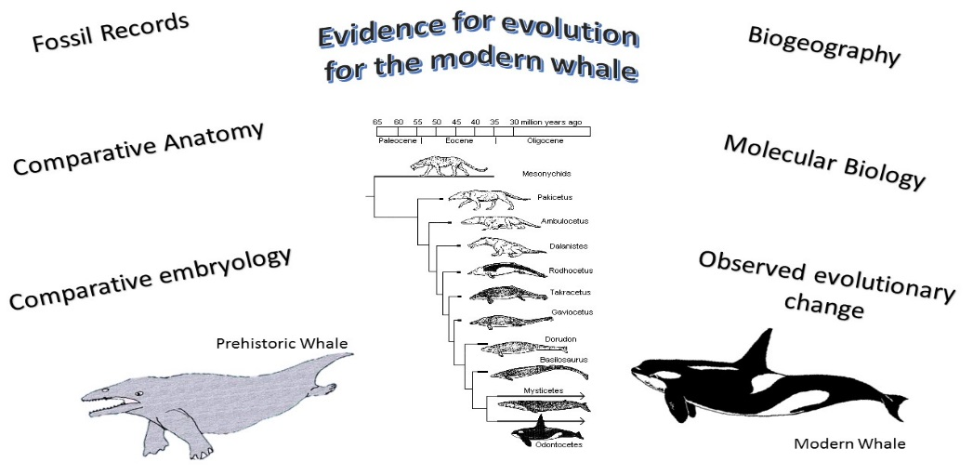
- Describe how scientific inferences regarding evolution are made from observations and identify examples from biology. (4-5 sentences, from the view point of your assigned unit of evidence)

- Units of evidence:

- Fossil Records
- Comparative Anatomy
- Comparative Embryology
- Biogeography
- Molecular Biology
- Observed evolutionary changes

- Unit of evidence summary must include:
- Description/definition of the assigned unit of evidence
- A summary of the evolution of assigned organism based on your unit of evidence – Example evolutionary information about the fossil record
- The “Think about it” question from the point of view of your assigned unit of evidence
Evidence for Evolution Poster Presentation Investigation (100 pts.)
A  (90-100 pts.) | B  (80-89 pts.) | C  (70-79 pts.) | D  (60-69 pts.) | F  (0-59 pts.)
Presentation is well done and/or neatly modeled. Roles were evenly shared. All qualifications are met/ exceeded. Unit of Evidence summary is completed thoroughly Explanations are in own words and clearly explains the topic. Vocabulary was used within correct context. | Presentation is well done and/or neatly modeled. Most qualifications were met. Unit of Evidence summary is complete or nearly complete with answers being somewhat thorough. Explanations are unclear and not put into own words. Vocabulary was used. | Presentation is not well done and/or neatly modeled. A few qualifications were met. Unit of Evidence summary was incomplete with some questions not being answered during presentation. Explanations are unclear, not being placed into own words, and are not present during presentation. Little to no vocabulary was used appropriately. | Presentation is not well done and/or neatly modeled. Very little qualifications were met for Unit of Evidence summary as well as during the presentation. Little to no vocabulary was used. | Presentation is not well done, not neatly modeled, is incomplete or not submitted at all. Qualifications are not met. Unit of Evidence summary is incomplete or not submitted at all. Explanations were not provided. No vocabulary was used.

Teacher Instructions/Grading Rubric
- Assign students to groups of 3-4, 3-member group is ideal. This will make each group member responsible for at least 2 units of evidence.
- Assign each group an animal to investigate _____________________________________
Fossil Record | Comparative  Anatomy | Comparative Embryology | Biogeography | Molecular Biology | Observed Evolutionary Changes
Contributor: | Contributor: | Contributor: | Contributor: | Contributor: | Contributor:
Rating: A-F: | Rating: A-F: | Rating: A-F: | Rating: A-F: | Rating: A-F: | Rating: A-F:
Individual Grade: | Individual Grade: | Individual Grade: | Individual Grade: | Individual Grade: | Individual Grade:

Evidence for Evolution Poster Presentation Investigation (100 pts.)
A  (90-100 pts.) | B  (80-89 pts.) | C  (70-79 pts.) | D  (60-69 pts.) | F  (0-59 pts.)
Presentation is well done and/or neatly modeled. Roles were evenly shared. All qualifications are met/ exceeded. Unit of Evidence summary is completed thoroughly Explanations are in own words and clearly explains the topic. Vocabulary was used within correct context. | Presentation is well done and/or neatly modeled. Most qualifications were met. Unit of Evidence summary is complete or nearly complete with answers being somewhat thorough. Explanations are unclear and not put into own words. Vocabulary was used. | Presentation is not well done and/or neatly modeled. A few qualifications were met. Unit of Evidence summary was incomplete with some questions not being answered during presentation. Explanations are unclear, not being placed into own words, and are not present during presentation. Little to no vocabulary was used appropriately. | Presentation is not well done and/or neatly modeled. Very little qualifications were met for Unit of Evidence summary as well as during the presentation. Little to no vocabulary was used. | Presentation is not well done, not neatly modeled, is incomplete or not submitted at all. Qualifications are not met. Unit of Evidence summary is incomplete or not submitted at all. Explanations were not provided. No vocabulary was used.

Overall Grade: ________________________ Notes:

