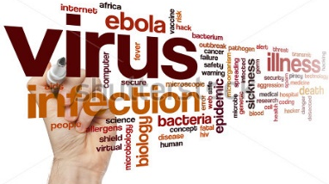
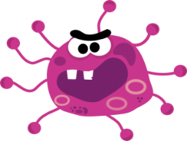
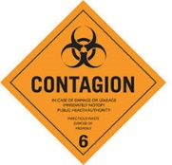
“Contagion” Movie Notes & Discussion Questions
Directions: Answer the following notes and video questions in complete sentences on your own paper.
- Should international gateways be closed in the event of an outbreak of a contagious disease?
- Copy the following statements and fill in the blanks:
  - Infectious diseases ________________________________.
  - Many organisms live in and on our bodies.
  - They're normally harmless or even helpful, but under certain conditions, some organisms may cause disease.
- What is Epidemiology? ___________________________
- Copy the following statements and fill in the blanks:
  - In epidemiology, the patient is part of the community and individuals are viewed collectively.
  - ______________________________________________
- Ethical Issues with Disease Control
  - ______________________________________
  - ______________________________________
  - ______________________________________
- Video Notes:
  - How was the disease spreading?
  - What were the signs and the symptoms?
  - What organization is involved in the tracking and monitoring of the disease? Where is it located?
  - What virus is the disease shown in the movie compared to?
  - What method was used to treat those effected?
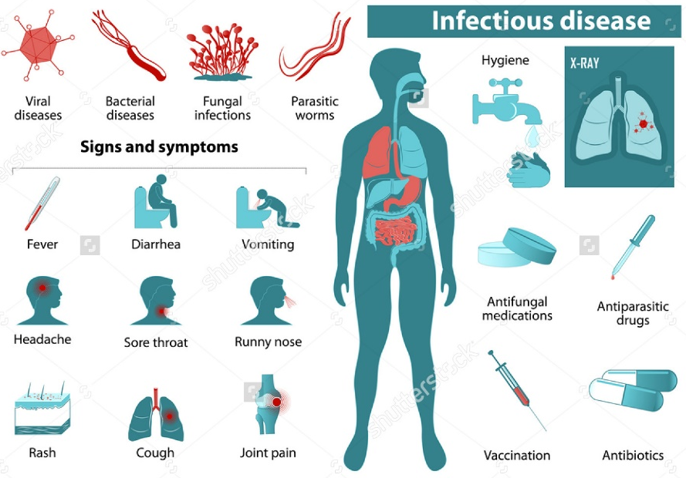
  - Why did Mitch not become infected with the disease?
“Contagion” Movie Activity - 50 Points

Directions: Your group will be randomly assigned to one of the TOP 10 DEADLIEST infectious diseases. Within your group create a plan to prevent and control infectious disease outbreaks. Consider the following questions and be sure to include the listed requirements.
Infectious Disease project:
- Is it ethical to close borders for international travel in the event of a disease outbreak? Is that the best method to control the spread of the disease?
- What is the infectious disease?
- What is the pathogen (agent) that causes your assigned infectious disease? Is it a virus, bacteria, parasite, fungus, etc.?
- Who are the typical hosts (people, animals, or plants)?
- What are some common symptoms of this disease?
- Is the disease curable? If so, how?
- How is the disease transmitted?
- How can the disease be prevented?
- What are some long-term effects of this disease on the individual, their family, and their environment?
- If your prevention and control plan fails, what will be your priorities to return society to a normal state?
  - Discuss and record your thoughts regarding:
    - Infectious disease control vs. people control
    - Individual interest vs. societal interest
    - Government responsibility vs. medical responsibility

