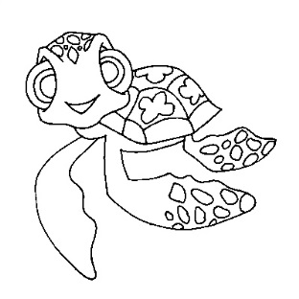
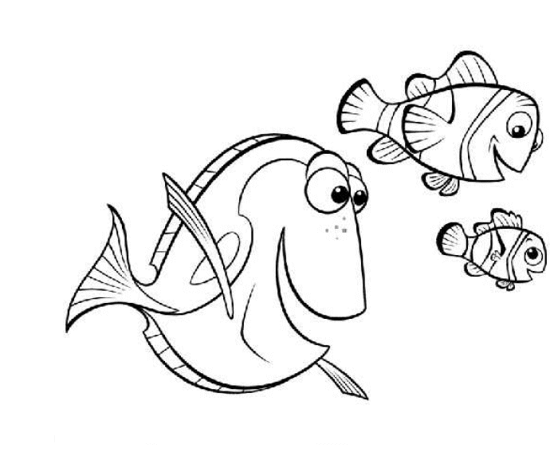
“Finding Nemo” Discussion Questions

- Tentacles of anemones are poisonous. Why are clownfish able to live among them?

- What is the base of the food chain in the ocean?

- What is the difference between a diurnal animal and a nocturnal animal?

- What must a predator have in order to be successful?

- Why does phytoplankton stay near the surface of the ocean?

- Which species is higher on the food chain, phytoplankton or zooplankton?

- How does a predator actually help the species of its prey?

- In the struggle between predator and prey is it always important for the individual prey to survive?

- Do sharks and the fish they eat have a symbiotic relationship?

- Describe how several types of coloration used by prey animals help them survive. Name at least two.

- What are the differences between a "commensal" relationship, a "symbiotic" relationship, and a "parasitic" relationship?

- How is a coral reef built?

- Name two enemies of coral reefs.

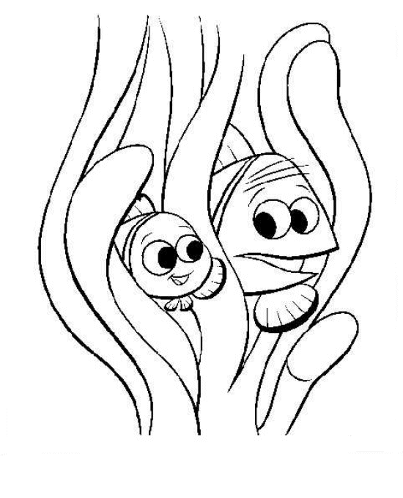
- Is coral an animal or a plant?

- Will it hurt a coral reef for you to walk on it?

