Planet Earth DVD – Jungles
Based on the BBC Planet Earth DVD
- Birds of paradise have some of the most elaborate coloration and mating rituals in the animal kingdom. For each of the birds of paradise shown, describe how it attracts a mate.

Riflebird of Paradise –

Six-Plumed Bird of Paradise –

Magnificent Bird of Paradise –

- The gradual regrowth of the rainforest plants after the large mature tree falls over is an example of secondary succession. List the pioneer species that emerge first, and the mature species that will eventually replace them.

 | Pioneer | Climax
Example Species
Characteristics

- There is a lot of interspecific competition between primates within the fig trees. Some of the primates rely on speed to gather as much food as possible, while others rely on size to chase competitors away. List two examples of each group.

Fast Primates Large Primates

- Explain how animals communicate in such a biologically dense ecosystem.

- What layer of the rainforest do gliding leaf frogs live in? ( Canopy / Understory / Forest Floor )

- What unusual physical adaptation do the gliding leaf frogs have?

- What abiotic factors within the rainforest create ideal conditions for decomposers?

- Explain how decomposers like the slime molds and veiled lady help to recycle nutrients within the rainforest ecosystem.

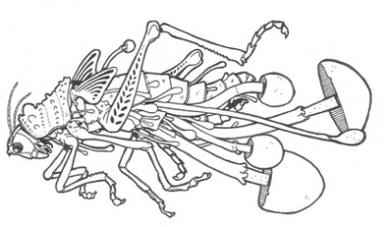
- Parasites like the cordyceps fungus are considered density-dependent limiting factors. Explain how this term applies to the bullet ants that the fungus invades.

- Describe the physical adaptation present in the colugo.

- Colugos and flying squirrels have similar adaptations, but they are not very closely related. This would be an example of ( divergent evolution / convergent evolution ).

- Carnivorous plants like the pitcher plant catch and digest insects mainly as a source of nitrogen, an important nutrient normally absorbed from the soil. Why might rainforest plants need this additional source of nitrogen?

- Describe how the red crab spider is adapted for its unique method of hunting.

- List two animals that migrate to the clearing.

- What essential nutrient is available at the clearing that attracts these animals?

- The last scene depicts two warring chimpanzee troops. Explain why these primates are so territorial, and why it is important to try to gain control over a greater area of the jungle.

