Planet Earth DVD – Seasonal Forests
Based on the BBC Planet Earth DVD
Taiga
- What type of trees are found in the taiga ecosystem?

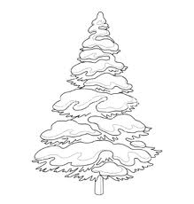
- Describe a few abiotic factors found within the taiga that limit its biodiversity.

- Lynx are solitary animals that sparsely populate the taiga. Why are their numbers so limited?

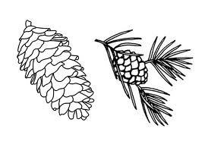
- Moose are one of the only animals of the taiga able to digest evergreen needles. What makes them so distasteful to other herbivores?

- What is the purpose of cones in evergreen trees?

- Give an example of a physical and behavioral adaptation shown by the wolverine.

- How might it benefit the capercaille species in the long run to have the males fight over the right to breed with the females?

Temperate Rainforests

- Give two limiting factors present in the temperate forests of the Pacific Northwest that allows the trees to grow so much taller than usual.

- Why are animals relatively scarce within the temperate rainforest?

- The pine marten’s food source varies by season. In the spring it relies on eggs. What about other seasons?

Temperate Evergreen Forest

- How are Monkey Puzzles similar to the coniferous trees of North America and Europe?

- Slender-billed parakeets and crossbills both have similar adaptations that allow them to eat the seeds of cones. Is this convergent or divergent evolution?

Temperate Mixed and Deciduous Forest
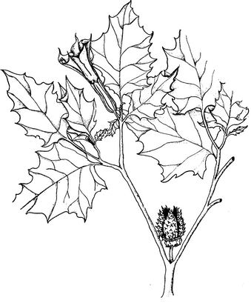
- What do the animals of the Valdivian forests of Chile have in common?

- Describe one advantage and disadvantage of the broad, flat leaves of deciduous forests.

- Periodical cicadas are slow, clumsy, and defenseless against predators. How are they able to survive and reproduce as a species?

- Explain how the fighting of the male red deer can result in the next generation having overall better genes.

- Describe the niche of the vultures and Amur leopards in winter.

- Why does it take longer for the Amur leopards to raise their young than African leopards?

- Why do deciduous plants produce brightly-colored, nectar-filled flowers?
- How does the lower layer of the deciduous forest compare with the canopy?

Tropical Deciduous Forest

- Why would a deciduous tree living in a tropical latitude need to drop its leaves?

- Explain the mutualistic relationship between langur monkeys and chital deer.

- What adaptations to Baobab trees have for surviving the dry seasons of Madagascar?

- Explain the mutualistic relationship between hawk moths, baobab trees, and mouse lemurs.

