Reproductive System Card Activity:
Teacher Instructions-
Pre- Lab-
1. Print a class set of cards on cardstock.
2. Cut the cards with the questions attached.
3. The cards can be folded with the questions behind the diagram or left with the diagram beside
the question.
During the Lab
1. Handout one card to each student.
2. Have the students answer the cards alone on a separate sheet of paper. Give them about 5
minutes. Lower level students may need a textbook or a resource.
3. Have the students separate by male reproductive cards on one side of the room and female
reproductive system on the other side.
4. Have like # numbered cards become groups and discuss their answers. (3-4 minutes)
5. Break into groups again - (depending on class size)
Group #1 – contains cards 1, 2, 3 and 4
Group #2 – contains cards 5, 6, and 7.
Group #3– contains cards 1, 2, 3 and 4
Group#4-– contains cards 5, 6, and 7
Students should share their questions and responses with the group.
6. Select groups to present their answers to the class. Be sure to correct mistakes, and give
feedback to responses

Formative Assessment- Teacher can choose the concept map or the ticket out the door.
Concept Map: http://www.classzone.com/cz/books/bio_12_fl/resources/htmls/interactive_review/bio_intrev.html
Section #1 Male and Female Reproductive System
Ticket out the Door:
Trace the path of sperm through the male reproductive system.
Teacher Instructions- Students can draw the pathway that sperm travel on paper, or Students can write a very short story of how sperm moves from the testes to Epididymis, vas deferens, and the urethra.

Reproductive System Anatomy Cards
1 | Questions  1. What is the function of Part A?  2. What is the function of Part B?  3. How is homeostasis maintained  by Part A?
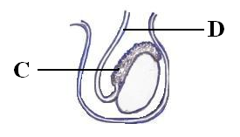  2 | Questions  4. What is the function of Part C?  5. What is the function of Part D?  6. List the structures that the sperm passed through to get to Part D.
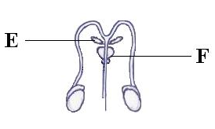  3 | Questions  7. What is produced in Part E?  8. What is produced in Part F?  9. Explain why these substances are  necessary for sperm to survive.
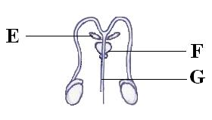  4 | Questions  10. What substances pass through Part G?  11. What are the two functions of Part G?
5 | Questions  12. What is produced in Part H?  13. What is function of Part I?
6 | Questions  14. What is the function of Part J?  15. How does Part J accommodate for the changes that occur during the embryological developmental stages of a human?
7 | Questions  16. What is Part J‘s role in the female reproductive system?  17. How does Part L assist in reproduction?

