Biology Review Day 5: Unit 4 Genetics, Ch 11
Answer your questions on your own paper! These are LONG answer questions!
- What influence did Gregor Mendel have on the study of genetics?
- How can I identify dominant and recessive patterns of inheritance?
- What type of letter is used for dominant traits?
- What type of letter is used for recessive traits?
- What type of trait is shown if an organism receives one of each: recessive and dominant, and why does this occur?
- What is a genotype?
- What is a phenotype?
- How can we predict inheritance of multiple traits using Punnett squares?
- How can I identify and predict offspring non-Mendelian crosses?
- How can we analyze how genetic traits and disorders are inherited using pedigrees?
- What is meiosis?
- What are the steps of meiosis?
- What are the products of meiosis?
- What similarities and differences exist between the processes of mitosis and meiosis?
- What is the relationship between meiosis and sexual reproduction?
- What is the role of crossing over in genetic variation?

Match the term with its definition.
Term Definition
17. genes A. Specific characteristics that vary among individuals
18. hybrids B. The offspring of true-breeding parents with different traits
19. traits C. Factors that determine traits
20. alleles D. Sex cells, egg or sperm
21. gametes E. The different forms of a gene

22. The dominant allele for smooth pod shape in peas is S. The recessive allele for constricted pod shape is s. In the Punnett square, show the result of crossing two heterozygous parents (Ss). Write the genotype and the phenotype of each type of offspring in the space provided.

 | S | s
S | Genotype:  Phenotype: | Genotype:  Phenotype:
s | Genotype:  Phenotype: | Genotype:  Phenotype:

- Complete the graphic organizer to summarize exceptions to Mendel's principle.
Mendel’s experiments cannot predict the outcome of traits that involve
Incomplete dominance
Example:
Example: Speckled chicken feathers from solid-color-feather parents
Multiple alleles
Example:
Example: Variety of skin color in humans

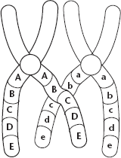
Use this diagram to answer Questions 18–20.
24.. What does the diagram show?

25. During what phase of meiosis does this process occur?

26. What is the result of this process?

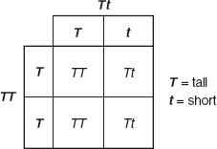
3. In the Punnett square shown in Figure 11–1, which of the following is true about the offspring resulting from the cross?
a. About half will be short.
b. All will be short.
c. About three fourths will to be tall.
d. All will be tall.

