Unit 3 Quiz
- The cell cycle is composed of….
  - Interphase and the M phase
  - Cytokinesis and Mitosis
  - Interphase and Cytokinesis
  - Prophase and Anaphase
Use the diagram below to answer the following questions:
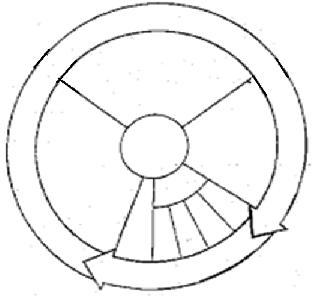
2..
6..
4.
5.
3.
- During this phase of the cell cycle, the cell grows, matures, and makes more cytoplasm and organelles.
  - G₀
  - G₂
  - G₁
  - S Phase
- During this stage of the cell cycle, the cytoplasm splits resulting in two identical daughter cells.
  - Prophase
  - Cytokinesis
  - G₂
  - S Phase
- The primary purpose of this stage is to prepare the cell for cellular division.
  - Mitosis
  - G₁
  - G₂
  - Metaphase
- This phase of the cell cycle consist of 4 stages, involving the condensing and the movement genetic material (DNA).
  - Mitosis
  - Anaphase
  - Interphase
  - Telophase

- During this phase of the cell cycle the genetic material (DNA) is copied or replication.
  - S phase
  - G₁
  - M phase
  - G₀
- What moves the chromatids during mitosis?
  - Organelles
  - Spindle Fibers
  - Chromosomes
  - Proteins
- What anchors the spindle?
  - Proteins
  - Centrioles
  - Chromosomes
  - Cytoplasm
- How many daughter cells are created from mitosis and cytokinesis?
  - 1
  - 2
  - 3
  - 4
- If a human cell has 46 chromosomes, how many chromosomes will be in the cell when it enters mitosis, how many chromosomes will be in each daughter cell respectively?
  - 46 and 46
  - 46 and 23
  - 92 and 23
  - 92 and 46
- Mitosis do not occur in which types of cells.
  - Sperm Cells
  - Egg Cells
  - Somatic Cells
  - Both A and B
- What is the correct order of Mitosis?
  - Prophase, Anaphase, Telophase, Metaphase
  - Metaphase, Anaphase, Telophase, Prophase
  - Prophase, Metaphase, Telophase, Anaphase
  - Prophase, Metaphase, Anaphase, Telophase
- Meiosis differs from mitosis because mitosis results in 4 identical cells while meiosis results in 2 different cells?
  - True
  - False

Use the diagram below to answer the following questions. Determine which stage of mitosis is each cell is displaying.
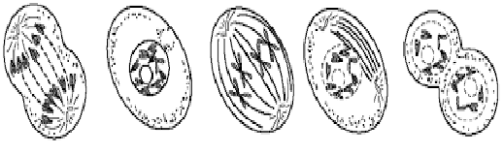
18..
17.
16.
15.
14.

- Prophase
- Metaphase
- Anaphase
- Interphase
- Telophase
19. What is the result of uncontrolled mitotic division?
a. Cancer
b. identical daughter cells
c. diploid cells
d. Haploid cells
20. Genetic mutations may result in the production of proteins that increase the probability that normal cell become cancerous.
a. True
b. False
Bonus Questions:
- What is the name of the protein that increase the probability that normal cell become cancerous.
- Which phase of the cell cycle does the cell spend most of its time?
- Describe the difference between the cellular division in Eukaryote vs. Prokaryotes (Honors must answer this question)

