Unit 4: ATP Guided Notes
Standard
- SC.912.L.18.10 ___________ the role of ________________________(ATP) to energy ___________ within a cell.
Guiding Question
- How do cells obtain and transform the energy required for biological processes?

Homeostasis is hard work. Organisms and the cells within them have to grow and develop, move materials around, build new molecules, and respond to environmental changes.
  - What powers so much activity, and where does that power come from?
    - Think for 10 seconds then be prepared for random calling!
Video 1
Video 2 Notes
- How does the athlete get his energy?
____________________________________________________________________________________
- The prefix tri- means ________________.
- When a cell needs energy, it gets it from ___________.
- What does the “D” stand for in ADP?
___________________
- We need the ________________________, an organelle, to make ADP back into ATP.

Fill-in-the-Blank PowerPoint
- Energy = the ability to do work
- Your cells are busy using energy to build new molecules, contract muscles, and carry out active transport.
- Without the ability to obtain and use energy, life would ______________________________________.
- One of the most important compounds that cells use to store and release energy is _____________________________________ (ATP).
- _______ consists of adenine, a ________________called ribose, and three phosphate groups.

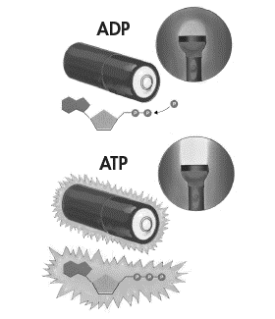
STORING ENERGY
- Adenosine diphosphate (ADP) looks almost like ATP, except that it has _____ phosphate groups _____________________________.
  - ADP contains ___________________________, but not as much as ATP.
- When a cell has energy available, it can ___________________________ of it by adding ______________________________ to ADP, producing ATP.
- ADP is like a _______________________________________ that powers the machinery of the cell.

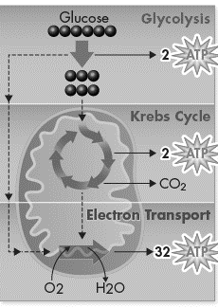
RELEASING ENERGY
- Cells can release the energy stored in ATP by ____________________________ the ____________ and ____________ phosphate groups.
- Because a cell can add or subtract these phosphate groups, it has an _____________________ way of storing and releasing energy as needed.

USING ENERGY
- One way cells _______________________ provided by ATP is to carry out __________________________________.
- Many cell membranes contain sodium-potassium pumps. ATP provides the _______________ that keeps these pumps working, _______________________________________________ of ions on both sides of the cell membrane.
- ATP __________________________, providing the energy for motor proteins that ______________________ and power the movement of ___________________________________.
- ATP is not a good molecule for storing large amounts of energy over the long term.
- It is more _______________ for cells to keep only a __________________________________ on hand.
- Cells can _______________ ATP from ADP __________________ by using the ________________________________ like _______________.

YOUR TURN
- Now you are going to create your own model of ATP
- You will need:
  - 1 sheet of yellow paper
  - Pencil
  - Scissors
- Fold the yellow paper hamburger style, then open it up
- Create the model by drawing the adenine first with its bond lines exactly as shown in the picture (use a half of the paper)

- Now make the 5-carbon sugar that we call ribose
- Create the model by drawing the adenine first with its bond lines exactly as shown in the picture (use a quarter of the paper)
- Finally, make the 3 phosphate groups
- Make 2 pieces like the pictures below on the remaining part of the yellow paper:

- Finally, make the 3 phosphate groups
- Make 2 pieces like the pictures below on the remaining part of the yellow paper:
- WRITE YOUR NAME ON EACH PIECE OF YOUR ATP MOLECULE!!

