TERM | Description | In your own words | Picture
Aerobic
Alcoholic fermentation
Anaerobic
Adenosine triphosphate
(ATP)
Cellular respiration

TERM | Description | In your own words | Picture
Cristae | Folds in the inner membrane of the mitochondria that allow for increased surface amount where multiple chemical reactions can take place | Inner membrane folds for more chemical reactions | 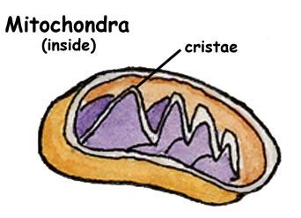
Electron transport chain
Fermentation
Glycolysis
Krebs cycle

TERM | Description | In your own words | Picture
Lactic acid
Matrix
mitochondria

