Unit 5: Meiosis Guided Notes
Standards – As a student, I should be able to…
SC.912.L.16.16 __________________________________, including ________________________________ and __________________________________. Explain how reduction division results in the formation of __________________________________ or spores.
SC.912.L.16.17 _____________________________ mitosis and meiosis and ________________________________________________________________________ reproduction and their consequences for _____________________________________.
Guiding Questions – As a student, I should be prepared to correctly answer the following on a test:
- What is the relationship between meiosis and sexual reproduction?
- What is the relationship between meiosis and the formation of haploid gametes or spores?
- What is the role of crossing over in genetic variation?
- What similarities and differences exist between the processes of mitosis and meiosis?
What is the relationship between meiosis and sexual reproduction?
- ___________________ = the process of reduction division in the body’s sex cells
  - ________________________________ = the ____________________________ we began with in the diploid (2n) parent cell is halved to _________________________ in the haploid (1n) gamete cells/sex cells/spores (ex. __________&____________)
- ______________________________________________ UNLIKE mitosis, which is a cycle
- The purpose is to ________________________________________________________________________
- ______________ = a cell containing ________________________________________________________________________
- Represented by the symbol ________________, includes body cells like skin and hair
- ________________________________________________________________________
- ____________________________________ = there are _________________________________________ involved in making the daughter (new) cells’ DNA set
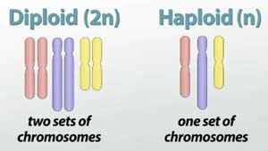
- _______________ = a cell with a _________________________ of chromosomes from _________________________
  - Represented by the symbol ___________, includes sperm (_________) & egg (________) cells only
  - ___________________________________________________________________
- ______________________ = formation of sperm ________________________________________________________________________
- ____________________ = egg formation _____________________________________, is completed after puberty; _________________________________________________ from each germ cell
- By the end of Meiosis II, the ____________________ that entered meiosis ________________________________________________________________________
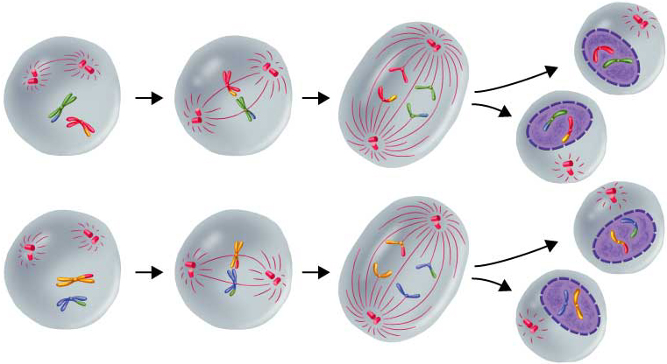
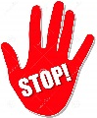

What is the relationship between meiosis and the formation of haploid gametes?
MEIOSIS 1
Prophase 1
- Corresponding homologous chromosomes from each parent pair up to form ______________________________________
- When homologous chromosome overlap it’s called ______________________________
- Crossing over happens when ________________________________________________________________________ after overlapping
- __________________________________________________________________________________________________________ (Think WAYYY back to biodiversity in ecology)
- ____________________________________________________ from his or her parents _______________________, to varying degrees, than the combination a sibling may get
Metaphase I
- _____________ = _______________
- The ________________________________________________________________
- _______________________________________________________ of the cell along the metaphase plate
Anaphase I
- The spindle fibers _________________________________________________________
- Each homologous chromosome is ____________________________________________
- _______________________________________________________ the spindle fibers to the homologous chromosome before they start to pull, then a nondisjunction will occur
- ________________________________________________________________________________________________________________________________________________
Telophase I & Cytokinesis
- ___________________ – the cell creates a _____________________________________ around the two homologous chromosome sets
- _________________ – the cell ______________________________________________.
MEIOSIS 2
- The two new cells produced by meiosis I now enter a second meiotic division
- The cells do NOT replicate DNA ______________________________________________
- ________________________________________________________________________
- _________________________
Prophase 2
- ________________________________________________________________________
- Similar to Prophase of Mitosis
- ________________________________________________________________________
Metaphase 2
- Similar to Metaphase of Mitosis
- Centrioles use spindle fibers to ______________________________________________ at the metaphase plate
Anaphase 2
- The centrioles use the spindle fibers to ________________________________________ into individual chromatids
- ______________________________ is pulled to the opposite pole of the cell
- ________________________________________________________________________________________________________________________________________________
Telophase 2 & Cytokinesis
- ________________ – the cells create a ______________________________ around the two haploid chromosome sets
- ________________ – the cells divides into _____________________________________

What similarities & differences exist between the processes of mitosis and meiosis?
 | Mitosis | Meiosis
Number of Starting cells
Number of ending cells
Number of Human Chromosomes
Genetic Make up of cells
Type of cells

