Name _________________________________________________ Date ____________________________________ Period __________
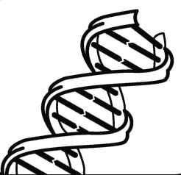
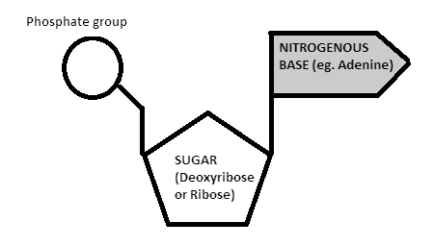
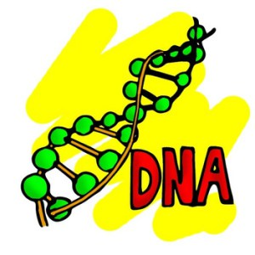
5E Lesson UNIT 6 – Nucleic Acids: DNA
Standard – As a student, I should be able to…
SC.912.L.16.3 _________________ the basic process of DNA ___________________ and how it relates to the ________________________ and _______________________ of the genetic ________________________.
Guiding Questions – As a student, I should be prepared to correctly answer the following on a test:
- What is the ________________________________________________ of DNA?
- _______________ does DNA replicate?
- How does DNA ____________________?
- How is DNA replication a __________________________________________________________?
What is the structure & function of DNA?
- DNA stands for Deoxyribonucleic acid
- It is the ____________________________________ found in ______________ living organisms and viruses (non-living)
Evaluate
- Which macromolecule includes DNA?
  - Lipids
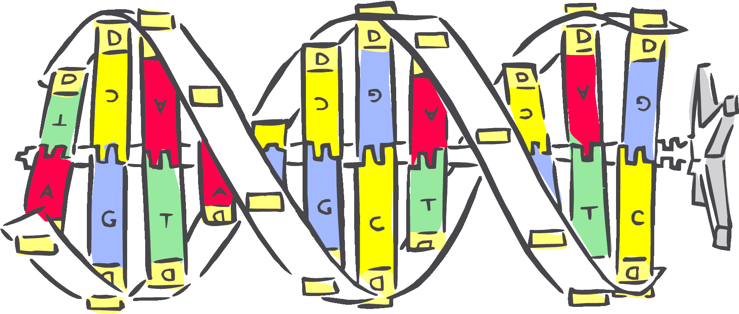
  - Carbohydrates
  - Proteins
  - Nucleic acids

- DNA is made of the following ______________________:
  - ______________________ = 5-carbon sugar
  - ________________________________
  - ______________________________________(4 total)
- ________________________________ used a method called ________________________________ to find clues about DNA structure
- The picture shows that the strands are twisted into coils, or a helix
- The angle suggests _____________________________
- _____________________________ built __________________________ of DNA
- They used Franklin’s model to determine that DNA was a ______________________, like a ______________________
- Watson & Crick’s findings supported that of another scientist, Erwin Chargaff
- ___________________________ states that certain nitrogenous bases always pair together by ____________________
  - ___________________________
  - ___________________________
STOP & THINK Complete the activity with your partner using the smartboard and dry-erase boards
- DNA makes up genes and performs the following tasks:
- _________________________________ = contains instructions for cell jobs and traits
- _________________________________= before cells divide, they must make a complete copy of every single one of its genes
- _________________________________= genes are passed on from one generation to the next (Mendel), DNA must be carefully sorted and passed along during cell division
STOP & THINK Complete the activity below
- List the 3 major components of DNA structure.
__________________________________________________________________________________________________
- When cells divide in mitosis, why is it important for them to make a copy of all genes in its DNA?
__________________________________________________________________________________________________
- How is DNA transmitted? Hint: are sperm & eggs haploid or diploid?
__________________________________________________________________________________________________

When does DNA replicate?
- Think back to the cell cycle including Mitosis…
- DNA is replicated or __________________ during ___________________________________________ of the cell cycle
- This is a part of Interphase
How does DNA replicate?
- Each base on 1 strand pairs with only one base on the ________________________ strand
- Because _______________________________________________________________________________, they are said to be _______________________________
- Enzymes separate (______________) the strands by __________________________________________ between them
- As each new strand forms, new bases are added following the rules of base pairing
STOP & THINK Complete the activity below
- In what phase of the cell cycle does DNA replicate? _______________________________
- Since bases on each strand pair up, what do we call the two strands of DNA? ________________________
- How do we open the DNA to copy the strands?
__________________________________________________________________________________________________
- ________________________________ is an enzyme that joins individual nucleotides to produce a new strand of DNA
- It also “_____________________” each new DNA strand, ensuring that each molecule is a perfect copy of the original
How is DNA replication a semi-conservative process?
- The end product of DNA replication includes __________________________________________________ of DNA
- This process is ___________________________ = each strand contains an __________________________________
